SCCU Policies & Procedures Manual
Created: February 25, 2016
Updated: March 9, 2016
Table of Contents
- FDLP Information
  - “Legal Requirements & Program Regulations of the Federal Depository Library Program”
  - FDLP Guidance Article: “Bibliographic Control” (Last Updated: January 6, 2016)
  - FDLP Guidance Article: “Shipping Lists” (Last updated: October 26, 2015)
  - FDLP Guidance Article: “Processing Depository Shipments” (Last updated: February 14, 2013)
  - FDLP Guidance Article: “Bibliographic Cataloging: Congressional Material” (Last updated: September 1, 2015
  - FDLP Guidance Article: “Name Authorities: Policy Overview” (Last updated: January 5, 2016)
  - FDLP Guidance Article: “Bibliographic Cataloging: Serials” (Last updated: September 1, 2015)
  - “Best Practices for Storing and Retrieving Depository Materials in On-Site and Off-Site Storage (Final)”, November 4, 2015
- Procedures: Federal Documents
  - Procedure for Processing Federal Gov Doc Hearings
  - How to Handle Multi-Part Holdings
  - Congressional Record Processing
  - Federal Register Processing
  - General Information
    - Book Jackets
    - Call Numbers
    - OCLC Updating
    - Holdings
  - Moving Items (from Aleph@UF?)
  - Item Records Main Page (from Aleph@UF?)
  - Procedures for Processing STAR Prints
  - Circulating Government Documents
  - Cataloged Documents Processing Checklist
  - Item Description Auto Fill Feature in Aleph
  - Deleting Holdings Records
  - Overlaying a Record in Aleph
  - Serial Set Cataloging Procedures
  - Shared Bib Guidelines 3.1.1 Local Notes
- Procedures: European Union (EU) Documents
  - Processing: EU Documents
- Procedures: Florida Documents
- Procedures: Urban & Regional Planning (Planning) Documents
  - Planning Collection Call Number Conversion Chart/Information
  - Preparing Materials for FLARE (Created: 3/9/2016)
- Procedures: CARP
- Procedures: Storage Material (Non-government documents)
- Family Search
  - Family Search Work Flow
- Shared Collections Cataloging Unit Information
  - New Employee Checklist
- FLARE Policies & Procedures
  - Federal Government Documents Transfer Guidelines
- Helpful Aids
  - MARC Holdings Cheat Sheet
  - Abbreviations for Captions
  - Serial or Monograph? Points to Ponder
  - Serials Holdings: Defaults and Basics
  - Abbreviations (Same as Abbreviations for Captions?)
  - Captions for Months/Foreign Months
  - HOL Local Input Standard (from Aleph@UF?)
  - Macros*Stamps*Tray Area Chart
  - Links to Helpful Information
  - Federal Documents Quality Control
  - Editing the 008 (Fixed Length Data) in the HOL
  - Serials with two SuDoc Call Numbers
  - Withdrawals from Ames
- Training Materials & Power Point Presentations
  - Intro to FLARE & 583’s
  - Intro to Gov Docs
  - Searching for Government Documents

Procedure for processing Federal Gov Doc Hearings
- Open Aleph Prod Client and log in
- Scan barcode on item into Item Bar Box
  - If no barcode or item doesn’t exist, search by title or call number
- Navigate to the Bibliographic record (Paper & pencil icon in top right corner)
- Check the following fields:
  - 007 Field denotes microfiche
  - 035 Verify OCLC number is correct; no “X” at the end (If so, See Overlay Procedure)
  - 086 If no 086, please add. First indicator is 0. (See guidelines for formatting SuDoc #)
  - 245 Should not have a subfield h microform (If it does, See Overlay Procedure)
  - 260
  - 300

- Verify the document is “Held” in OCLC
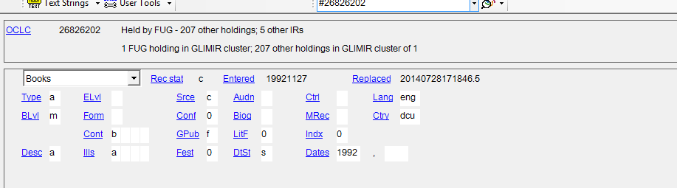

- If BIB record is correct and does NOT need overlaying , continue to Step 10
- If error has been identified in ALEPH and OCLC follow the steps below on how to correct:
  - If the OCLC record is a PCC record and changes can’t be saved, send an email to jodyb@uflib.ufl.edu and give the hearing to Jody. Include the following information:
    - OCLC #
    - A detailed description of the error that needs to be corrected
    - A confirmation that the purl link (if available) has been verified and matches physical item.
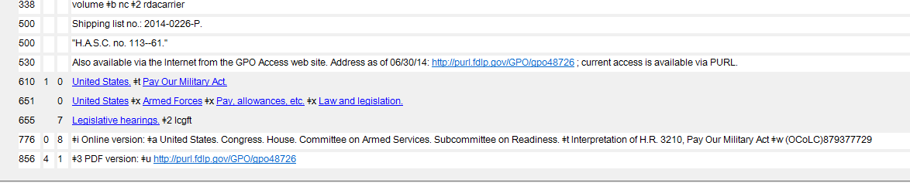

    - If purl link is absent from record, let Jody know in the email.
    - Jody will process the record to completion.
  - If the OCLC record is not a PCC record, make appropriate corrections and replace record.
    - Overlay Aleph record (See Overlay Procedure)
    - Make note of the overlay in the work logger Notes field
- If BIB record needs to be overlaid, check/perform the following in OCLC and then follow the Overlay Procedures:
  - F7 – Spell check
  - F11 – Validates 110 and 650 fields
  - Validate whole record
  - Control headings
  - Replace record if changes were made (Under Actions)

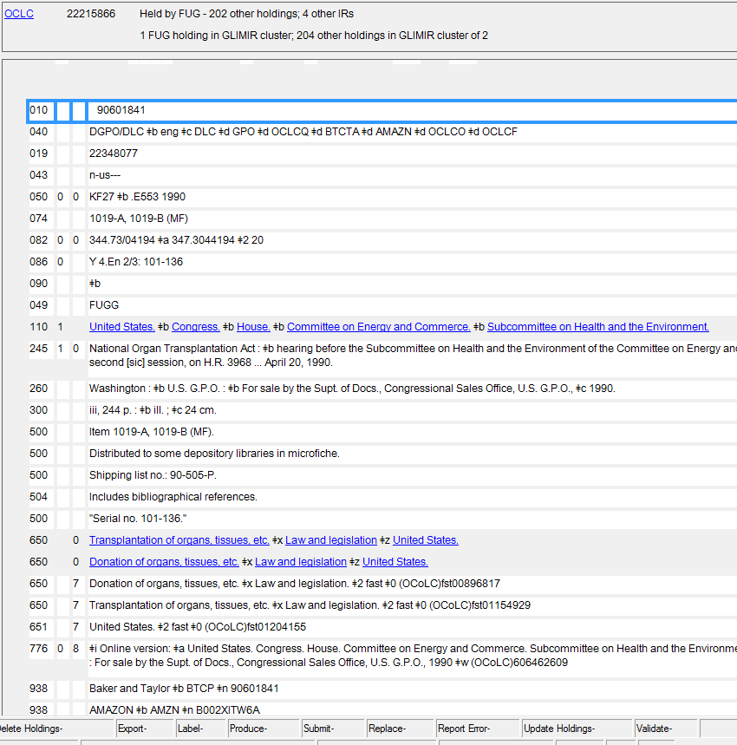
Typical OCLC Record

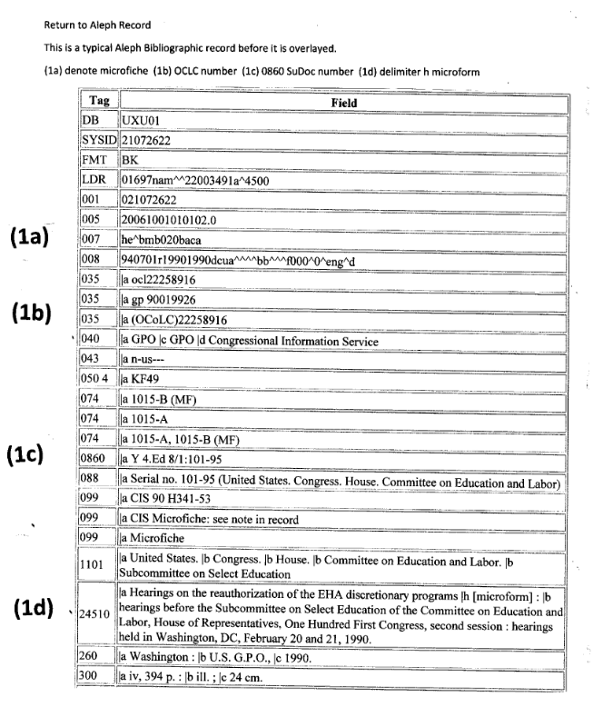
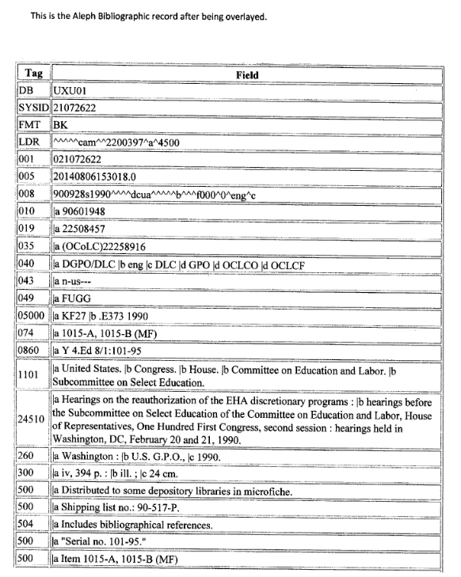

- Complete Post Overlay Cleanup
After you overlay the Aleph bibliographic record you will want to remove the extraneous 500 fields. Find the 599 element. Usually the 599 will land in the bib record at the same place you put it into the OCLC record i.e. after the last 500 field. Highlight all of the 500 fields after this point. Use Control F5 to delete these extraneous 500 fields. Save record to the server.
There are times when the 599 for which ever reason will land at the bottom of the 500 fields. You can delete the extraneous 500 fields using the Control F5 combo.
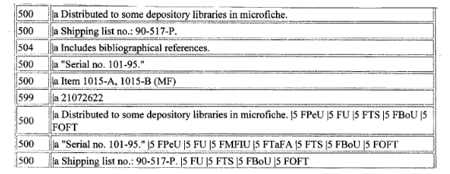
DO NOT DELETE!!
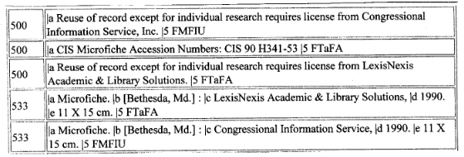

- Open Holding record
- If holding is UFSTO GEN, make the following edits:
  - 852 should have a “3” in the first indicator (“3” represents SuDoc)
  - Run the TKR Hearing macro
  - Run the Stodocs Statistics macro
- If there isn’t a UFSTO GEN holding, create a new holding
  - Complete step 11 a-d
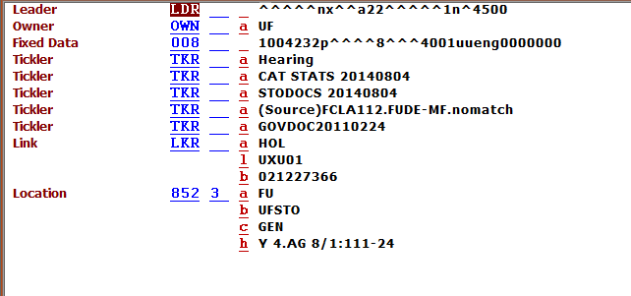
[11c]
[11d]
[11b]
[11a]

- Navigate to Item Record screen
- Locate existing item record.
  - If no item exist, create a new item
- Set Item Process Status (IPS) to GF
- Scan in barcode if not previously scanned
- Update
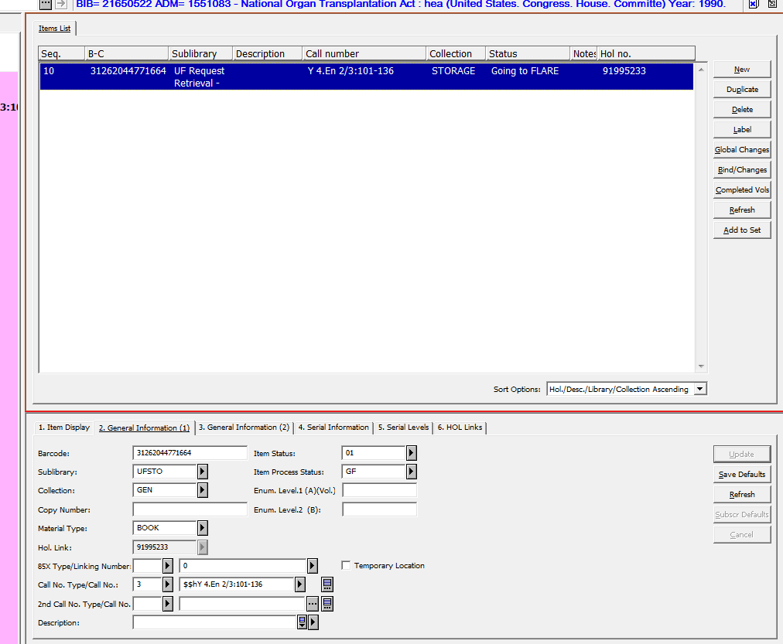

- Complete the following physical processing:
  - If call number is not on item, write it in the top left corner
  - Make sure item has Depository Stamp on front cover. If not, stamp item
- Place completed item(s) on finished cart (usually next to Paige’s desk) or on cart in the Gov Docs tray area.

Processing Federal Documents – Hearings (Y 4’s): Monographs
Bibliographic Record:
- Check the following fields:
  - 035: Verify OCLC number is correct; no “X” at the end (If it does, overlay the record)
  - 086
  - 245 Should not have a subfield h microform (If it does, overlay the record)
  - 260/300
- Verify the document is “Held” in OCLC
Holding Record:
If there is a UFSTO, GEN holding, change it to the following:
- 852 field should have a “3” in the first indicator (“3” represents SuDoc)
- Insert TKR Hearing
- Run the Stodocs TKR macro
- Run the Stodocs statistics macro
If there isn’t a UFSTO, GEN holding, create a new holding
Item Record:
- Item Status should be “01”
- Material type should be “book”
- Type “GF” in the Item Process Status
- Update the item record
Physical Processing:
- Must have a call number (label or handwritten on upper left-hand corner of cover)
- Must have a “U.S. Depository” stamp

Updated 7/14/2014
Processing Hearings Monographic Sets (Same Hearing Number):
Bibliographic Record:
- Check the following fields:
  - 035: Verify OCLC number is correct; no “X” at the end (If it does, overlay the record)
  - 086
  - 245 Should not have a subfield h microform (If it does, overlay the record)
  - 260/300
- Verify the document is “Held” in OCLC
Holding Record:
If there is a UFSTO, GEN holding, update it to the following:
- 852 field should have a “3” in the first indicator (“3” represents SuDoc)
- Create a monographic 853/863 pair
- Insert TKR Hearing
- Run the Stodocs TKR macro
- Run the Stodocs statistics macro
If there isn’t a UFSTO, GEN holding, create a new holding
Item Record:
- Item Status should be “01”
- Material type should be “book”
- Type “GF” in the Item Process Status
- Description should include the part number
- Update the item record
Physical Processing:
- Must have a call number (label or handwritten on upper left-hand corner of cover)
- Must have a “U.S. Depository” stamp

Updated 7/14/2014
Processing Hearings Monographic Sets (Different Hearing Number):
Bibliographic Record:
- Check the following fields:
  - 035: Verify OCLC number is correct; no “X” at the end (If it does, overlay the record)
  - 086 Should have two 086 fields; one for each hearing number; if not, add 086
  - 245 Should not have a subfield h microform (If it does, overlay the record)
  - 260/300
- Verify the document is “Held” in OCLC
Holding Record:
- If there are two UFSTO, GEN holding records (one for each hearing number), update both holdings per the instructions below;
- If there is one UFSTO, GEN holding record, update the UFSTO, GEN holding per the instructions below for “Holding #1”;
- If there are no UFSTO,GEN holding records, create a new holding per the instructions for “Holding #1”
Holding #1
- 852 field should have a “3” in the first indicator (“3” represents SuDoc)
- Change the call number to reflect both hearing numbers using a slash
(For example, Y 4.B 22/3:S.Hrg.111-109 (Pt. 1) & Y 4.B 22/3:S.Hrg.111-137 (Pt. 2) would become Y 4.B 22/3:S.Hrg.111-109/137)
- Create a monographic 853/863 pair
- Insert TKR Hearing
- Run the Stodocs TKR macro
- Run the Stodocs statistics macro
Holding #2
- Delete holding record from the server
Item Record:
- Item Status should be “01”
- Material type should be “book”
- Type “GF” in the Item Process Status
- Description should include the part number with the hearing number in parenthesis i.e., pt.1(111-109)
- Update the item record

Physical Processing:
- Must have a call number (label or handwritten on upper left-hand corner of cover)
- Must have a “U.S. Depository” stamp
Auburn Hearings Processing
We are going to first go through monographs, and set aside the multi volume sets to process once the monographs are complete
- Search for the hearing in Aleph
- Record the following on the Auburn Hearing Processing google spreadsheet:
  - Aleph Bib #
  - OCLC #
  - SuDoc #
  - CIS (field number) (If present in fields 599, 035, 588)
  - FLARE? (Y or N)
  - Swap? (Y or N) Swap if already in FLARE, new and no swap if not in FLARE
  - Requested from Team Tray (date requested)
  - Received from Team Tray (date received)
  - Barcode
- Catalog the bib record as you would normally catalog a hearing
**Request and receive FLARE copy from Team Tray before proceeding to the Holding and Item Records**
- The subject of the request email to Lib-Alf Issues should be: Auburn Swap Request
  - The email for monographs should say: Please pull these items for swap (list barcode numbers)
  - The email for multi volume sets should say: Please PWD these barcodes for Auburn Hearings Project: (list barcode numbers)
- In the holding record check the 008, make sure the following fields are present:
  - Stodocs, hearings, catstats
  - 852 3 _
  - Complete call number
  - Add 852 x field notes:
    - 852 x hardbound
  - Add TKR sccumv (only to multi volume sets)
- Check 583 fields on FLARE side to make sure it contains:
  - Committed to permanently retain
  - FDLP
  - ASERL
- In the item record, duplicate the barcode for a monograph, and withdraw UF and FLARE items for a multi volume set
  - Multipart items: add new barcodes
- Once complete, give the hardbound copies that are replacing hearings in FLARE back to Team Tray
- Place any new hardbound hearings (not previously in FLARE) on the book cart for quality control
- For all hearings being replaced, mark over any UF barcodes and place in the stacks at the end aisle 117, separated by agency
Congressional Record Processing
The Congressional Record daily issues are received in the shipments from GPO. They do not have labels or barcodes. The Congressional Record daily issues should be processed as follows:
- Check-in all daily issues:
  - Use Aleph System #20904974
  - Update UFSTO, DOCS holding
  - Use 866 31 fields
  - Do NOT create an item record
  - Write call number on piece (X 1.1/A:)
  - Stamp with the U.S. Depos stamp
  - Shelve
- Withdraw daily issues when bound volume is received
  - Retrieve issues covered by bound volume
  - Delete holdings statements for daily issues to be withdrawn
  - Mark through stamp
  - Mark cover and title page with a large X
  - Recycle
Daily issues paper: Aleph System #20904974
Daily issues electronic version: Aleph System #30850943
Bound volumes: Aleph System #20165012

Additional processing will be provided for the bound editions and the microfiche.
Aleph System #’s for the bound edition electronic version and microfiche will be added.
Federal Register Processing
The Federal Register is published daily except weekends and official holidays. They do not have labels or barcodes. The Federal Register daily issues should be processed as follows:
- Check-in all daily issues:
  - Use Aleph System #20164639
  - Update UFSTO, DOCS holding
  - Use 866 31 fields
  - Do NOT create an item record
  - Write call number on piece (AE 2.106:)
  - Stamp with the U.S. Depos stamp
  - Shelve
Cataloged Documents Processing Checklist:
Bibliographic Record Checklist:
Check to make sure the bib has the following fields:
- 035: Contains valid OCLC #
- 086: Contains correct SuDoc call number
- 245: Title matches piece in hand
- 260: Date matches piece in hand
- 300: Number of pages matches piece in hand
- 500: Notes match information on piece in hand
Holding Record Checklist:
- 852: First indicator should be “3”; SuDoc call number
- Stats: If CATSTATS not in holding record, add by using SCCatStats
- TKR: If StoDocs not in holding record, add by using StoDocsTkr
Item Record Checklist:
- GF the item
Physical Processing:
- Stamp with U.S. Depository stamp
Overlaying a record in Aleph

Select record in OCLC
Select record to be overlaid in Aleph

If the OCLC numbers are the same, then it should not be necessary to add a 599 field in the OCLC record unless there is a duplicate record in Aleph.

In Aleph, remove any note fields (5xx) which are in the OCLC record. Please take care to retain any fields which have a $5 as these are local notes. If the local note is in the master OCLC record, then you may remove the field as this local note was probably created during the shared BIB merger.

In Aleph, change any 590 field to a 500 field and add the appropriate $5. A subfield 5 will not protect a 590 field during overlay.

Switch to your OCLC record

Add a 599 field to OCLC by hitting the enter key. While it is not necessary to add the 599 field at the end of all the other 5xx fields, it is more aesthetically pleasing. Both indicators should be black. In the main portion of the field COPY AND PASTE the 001 field from Aleph. It is very important to copy and paste this as any error in copying this number will cause the wrong record to be overlaid, and this can be very difficult to fix.

Press the “Export” button in OCLC. You should get a pop-up confirmation screen stating a matching record was found and replaced. You will notice that at the bottom of the OCLC screen, a “C” will appear after the word “Export”. If the export fails, you will see a message on the pop-up screen explaining why and the letter “F” will be at the bottom.

Shared Bib Guidelines 3.1.1 Local Notes

    - Local Notes

      - Use of $5 for Unique Content

In general, use $5 with the main campus library’s MARC Organization Code (not the OCLC holdings code) to preserve local content for the shared bib environment. Use of $5 should be confined to fields that reflect something unique about the library’s copy or use of the material. Many such fields refer to rare or archival copies, “bound with” materials, references to related materials in the library’s collection, and other pertinent local information. Fields marked with $5 to preserve local content during the initial merge of the shared bibliographic catalog are listed in Appendix III.

Do not use $5 based on a perception that your version of a standard note is superior to versions that may exist on other catalog records.

      - Editing local notes with $5

Do not edit notes with unique institutional content. Notes with obvious errors or non-unique content can be edited according to the guidelines in Section 3.6 on Record Enhancement.

This leads to 3.6.1.2 Retaining Existing Field Content

Retaining Existing Field Content

When editing an existing record, all original content is to be retained except in the instances listed below:
- Correcting errors
- Accommodating record size limit
- Obvious duplication of data with minor differences that do not substantially change the description of the material. These fields can be edited and merged, even if marked with a $5. Examples of fields that can be edited according to national standards include: 490/830, 504, 505, 520, 500 publication data, valid 856 fields linking to freely available content, etc. and the $5 should be removed so the edits are available to all SULs.
- Exercise caution when reviewing 505 fields since fields may be split between several tags. If there are multiple 505 fields duplicating the same content notes, delete the duplicated notes. In the case of duplicated contents notes split into multiple fields, it may be advisable to overlay the record.
- Using enhanced 505 fields for general chapter titles can cause irrelevant search results. 505 00 should only be used for titles of individual works and distinctive titles of volumes, for example conference papers, chapters written by different authors, individual titles of a compilation of works, and distinctive volume titles. If the bib record has both 505 00 and 505 0_ fields, keep the field that follows the guidelines above and delete the one that does not.

Unique institutional fields marked with $5 should always be retained. When in doubt, retain the content.

Processing: EU Documents
- Search the title in Aleph
  - If there is a good record in Aleph, proceed to Step
- Verify the Aleph record matches document in hand
  - Make sure there is an 035 field
  - Make sure the title matches
  - Make sure the date(s) match
  - Make sure the page numbering matches
  - Make sure any document numbers in 500 fields match
- Open the OCLC record
  - Spell check (F7)
  - Validate
  - Control Headings
  - Add UF holding
- Create a new holding
  - Add 852 subfield a,b,c as FU, UFSTO, EU
  - Add TKR EU Docs Trayed
  - Add cataloging statistics
- Create an item record
  - Add GF in the item process status
  - Add barcode
Physical processing:
- Stamp with EU depository stamp
- Write call number on the document
- Add to work logger
Florida Documents: Preparing Materials for FLARE
Created: 8/8/2016
- Locate the record in Aleph:
  - Scan the barcode
  - If there isn’t a barcode:
    - Search by title
    - Search by call number
      - In Aleph, choose “Call Number, Other (OTH)”
- Bibliographic Record Verification:
  - 035 (OCLC Number): Make sure there is one
  - 245 (Title): Make sure it matches piece in hand
  - 260/264: Make sure the date(s) match piece in hand
  - 300: Make sure the page numbering matches
    - Page numbering can be off by a few—don’t waste too much time concerned with page numbering
  - 500: Make sure information matches piece in hand
- OCLC:
  - Copy OCLC number from bibliographic record (035 field)
  - Paste into OCLC
  - Verify record is “Held by FUG”
    - If not, update holdings
  - Run Spell Check (F7)
  - Validate record
  - Control All Headings
  - Replace record
    - Under Action → Replace Record OR
    - Alt + F10
- Holding Record:

  - 852: First indicator “8”
  - Location=UFSTO, DVER
  - Call Number: Make sure call number matches piece in hand
    - Subfield “x” should say “FLORIDA DEPOSITORY”
  - Run SCCatStats macro
  - Add TKR
    - FLORIDA DEPOSITORY
- Item Record:
  - Material Type
    - Monograph=Book
    - Serial=Issue
    - Bound serial=Issbd
  - Hol. Link: Should match correct holding for piece in hand
  - Call Number: Should match holding record call number
  - Item Status: 01 (Regular Loan)
  - Item Process Status
    - Add GF
- Physical Processing
  - Stamp with “Florida Depository” stamp (if it doesn’t have one)
  - Stamp with “FLARE” stamp
  - Write the call number on the piece
    - Location: top, left-hand corner
    - If dark or hard cover, write call number on inside, first page
  - Add to the work logger on the tab for “Florida Documents”
- Team Tray
  - Deliver completed material to Team Tray
    - Monographs: SCF cart
    - Serials: SER cart

Urban & Regional Planning Documents: Preparing Materials for FLARE
Created: 3/9/2016
- Locate the record in Aleph:
  - Scan the barcode
  - If there isn’t a barcode:
    - Search by title
    - Search by call number
      - In Aleph, choose “Call Number, Other (OTH)”
- Bibliographic Record Verification:
  - 035 (OCLC Number): Make sure there is one
  - 245 (Title): Make sure it matches piece in hand
  - 260/264: Make sure the date(s) match piece in hand
  - 300: Make sure the page numbering matches
    - Page numbering can be off by a few—don’t waste too much time concerned with page numbering
  - 500: Make sure information matches piece in hand
- OCLC:
  - Copy OCLC number from bibliographic record (035 field)
  - Paste into OCLC
  - Verify record is “Held by FUG”
    - If not, update holdings
  - Run Spell Check (F7)
  - Validate record
  - Control All Headings
  - Replace record
    - Under Action → Replace Record OR
    - Alt + F10
- Holding Record:
  - 008: See “Editing the 008” Procedure
  - 852: First indicator “8”
  - Location=UFSTO, PL
  - Call Number: Is the call number from the old system or new system?
    - New system: County is spelled out
    - For more information, see “Urban & Regional Planning Documents Call Numbers” in SCCU Policies & Procedures Manual
  - Run SCCatStats macro
  - Add TKR
    - Planning Documents
- Item Record:
  - Material Type
    - Monograph=Book
    - Serial=Issue
    - Bound serial=Issbd
  - Hol. Link: Should match correct holding for piece in hand
  - Call Number: Should match holding record call number
  - Item Status: 01 (Regular Loan)
  - Item Process Status
    - Add GF
- Physical Processing
  - Stamp with “Urban & Regional Planning Documents” stamp (if it doesn’t have one)
  - Stamp with “FLARE” stamp
  - Write the call number on the piece
    - Location: top, left-hand corner
    - If dark or hard cover, write call number on inside, first page
  - Add to the work logger on the tab for “Planning Documents”
- Team Tray
  - Deliver completed material to Team Tray
    - Monographs: SCF cart
    - Serials: SER cart
Federal Government Documents in FLARE: Transfers
Created: November 14, 2016
(Sidenote: This procedure will be updated once we migrate to Sierra)
BACKGROUND:
The Shared Collections Cataloging Unit is responsible for cataloging federal government documents into FLARE. Federal government documents are ingested into the customer code GOV in LAS. Some federal government documents received in transfers from other institutions are misidentified and processed into a non-GOV customer code in LAS.
Test Case:
Monthly Labor Review (23373960)
University of Miami (UM) transferred a portion of this serial title per FLARE policy and volumes were processed into the customer code for serials in LAS. The Shared Collections Cataloging Unit began cataloging UF’s set of this title and realized part of it was already in FLARE in the customer code for serials in LAS. The Shared Collections Cataloging Unit received mail bins from ILF processors with more volumes of this title from the University of Miami transfer. Basically, we have UM transferred material already processed into FLARE with the serials customer code, UF material at ALF to be processed and UM transferred material to be processed into FLARE. All volumes need to be in the GOV customer code in LAS.
PROCEDURE:
Transferred material is identified as a federal government document by Interim Library Facility (ILF) processors and sent to the Shared Collections Cataloging Unit in a mail bin with a pink dot on it. [The pink dot is a suggestion from the Shared Collections Cataloging Unit; we have a box of pink dots that could be used. It would be easier to identify the material when received at ALF]
A Shared Collections cataloger will search the title in Aleph and compile a list of barcode numbers for all documents that need to be transferred to the GOV customer code in LAS. The list of barcodes will be sent to the lib-ALFissues mailbox.
Team Tray will permanently withdraw (pwd) the barcodes provided from their current customer code and deliver the material to the Shared Collections Cataloging Unit.
The Shared Collections Cataloging Unit will move the transferring institution’s barcode number into the internal note field in tab 3 of the item record (formatting for internal note in tab 3 is: **barcode number transferring institutions initials**; for example, 3505********* UM). The transferring institutions barcode will remain on the document with the barcode scanning information blacked out but the barcode number still visible. The cataloger will affix a UF barcode to the back of the book and update the item record with the new barcode. The bibliographic and holding record will be updated to reflect that it is a federal government document. The documents will be stamped with the U.S. Depository stamp and the FLARE stamp.
Once material processing is completed, it will be placed on the book truck for federal government documents going to Team Tray.
Federal Documents QC
Bibliographic Record:
- 035: Verify OCLC number is correct (you might find an “X” at the end of the number)
- 086
- 245 Should not have a subfield h microform
Holding Record:
- Stodocs Location
- Stodocs TKR
Item Record:
- “GF” in the Item Process Status
Circulating Government Documents
The patron will request a government document through the library catalog. The patron will submit the request in one of the following ways:
- Request the government document using the “Request” link on the catalog record or in the search results list.
- Request the government document using the alternative form. The alternative form should be used when the “Request” link does not appear, the patron doesn’t have an active library card, or multiple years/volumes are needed. The alternative form can be found at http://www.uflib.ufl.edu/storagerequest/.
Government Documents will be retrieved from storage Monday – Friday and sent to Library West for pick up. Please allow 24 hours for your request. The patron can check the status of the request in their library account. The patron will see “On Hold” in their library account when the government document is ready for pick up at Library West. The patron will see “In Process” in their library account if the government document is not yet available for pick up. The patron will not receive an e-mail when the government document is ready for pick up.

ALF Storage Staff & Shared Collections Cataloging Unit:
ALF storage staff will receive the request and deliver it to the Shared Collections Cataloging Unit. The Shared Collections Cataloging Unit will catalog the government document and add “SD” to the Item Process Status. Once cataloged, the Shared Collections Cataloging Unit will return the government document to ALF storage staff to be delivered to Library West.
The patron will then check the government document out in Library West as any other retrieval. The patron will return the government document to the libraries and it will be sent back to ALF. ALF staff will add “GF” to the Item Process Status and deliver it to the Tray Team. The government document will then be added to the FLARE collection.
MARC Holdings cheat sheet
Official guide:
http://www.uflib.ufl.edu/catmet/sercat/SerHolDefaults.htm

LDR
Type: x = monograph (default), y = serial, v = multi-part monograph
Enc lvl = 4 for ALF staff ; 3 for ILF staff

008
Receipt or acquisitions status
2 = Monograph OR a serial that we will not get any more (default)
Method of acquisition
p = Paid
d = Depository item (Gov docs)
u= Unknown
Expected acquisition end date
DO NOT CODE – leave blank
General retention policy
8 = Permanently retained
Completeness
0 = unknown 1 = Complete
4 = single-part monograph 2 = Incomplete
No. of copies
001
Lending policy
u
Reproduction policy
u
Language
eng (English - only change for serials, leave monographs alone)
fre – French
ger – German
ita - Italian
por – Portuguese
rus - Russian
spa - Spanish

Abbreviations for captions:
http://guides.uflib.ufl.edu/captions
Abbreviations for foreign months:
http://guides.uflib.ufl.edu/foreignmonths

Multi-part monograph holdings
853 00 8 1 $$a v. (or pt. or t. or ed. etc....)
863 20 8 1.10 $$a ___

Serials
853 00 8 1 a (year) - Annuals, regardless of language!

853 00 8 1 a no. $$i (year)
853 00 8 1 a + $$i (year) with ordinal number
853 00 8 1 a + ed. $$i (year) with ordinal edition, 1st, 2nd, 3rd, 4th ed.
853 00 8 1 a + año. $$i (year) [SPANISH]
853 00 8 1 a + ed. $$i (year) [FRENCH]
853 00 8 1 a + ano. $$i (year) [PORTUGUESE]
853 00 8 1 a + Bd. $$i (year) [GERMAN]

853 00 8 1 a v. $$b no. $$i (year) $$j (month) [ENGLISH]
853 00 8 1 a año $$b no. $$i (year) $$j (month) [SPANISH]
853 00 8 1 a t. $$b no $$i (year) $$j (month) [FRENCH]
853 00 8 1 a ano. $$b no. $$i (year) $$j (month) [PORTUGUESE]
853 00 8 1 a Bd. $$b Aufl. $$i (year) $$j (month) [GERMAN]

853 00 8 1 a v. $$b no. $$i (year) $$j +qtr. [ENGLISH]
853 00 8 1 a año $$b no. $$i (year) $$j +trim. [SPANISH]
853 00 8 1 a t. $$b no $$i (year) $$j +trim. [FRENCH]
853 00 8 1 a ano. $$b no. $$i (year) $$j +trim. [PORTUGUESE]
853 00 8 1 a Bd. $$b Aufl. $$i (year) $$j +Quartal [GERMAN]

853 00 8 1 a v. $$b no. $$i (year) $$j (month) $$k (date) [ENGLISH]
853 00 8 1 a año $$b no. $$i (year) $$j (month) $$k (date) [SPANISH]
853 00 8 1 a t. $$b no $$i (year) $$j (month) $$k (date) [FRENCH]
853 00 8 1 a ano. $$b no. $$i (year) $$j (month) $$k (date) [PORTUGUESE]
853 00 8 1 a Bd. $$b Aufl. $$i (year) $$j (month) $$k (date) [GERMAN]

853 00 8 1 a ser. $$b v. $$c no. $$i (year) $$j (month) $$k (date) [ENGLISH]
853 00 8 1 a epoca $$b año $$c no. $$i (year) $$j (month) $$k (date) [SPANISH]
853 00 8 1 a nouv.sér. $$b t. $$c no $$i (year) $$j (month) $$k (date) [FRENCH]
853 00 8 1 a epoca $$b ano. $$c no. $$i (year) $$j (month) $$k (date) [PORTUGUESE]
853 00 8 1 a Folge $$b Bd. $$c Aufl. $$i (year) $$j (month) $$k (date) [GERMAN]

Macros Stamps Tray Chart
The following chart shows which macros and stamps catalogers should use depending on the type of material. It also shows where to put the material once it has been cataloged.

Type of Material | Macros | Stamps | Tray Area
Federal Hearings | Hearing Tkr | Federal Depository | Gov Docs
 | SCCatStats | FLARE (when received)
Federal Documents | StoDocsTkr | Federal Depository
(Not Hearings) | SCCatStats | FLARE (when received) | Gov Docs
European Union (EU) | EU Docs Trayed Tkr | EU Depository | Monographs: SCF
 | SCCatStats | FLARE (when received) | Serials: SER
Florida Documents | FLORIDA DEPOSITORY Tkr | Florida Depository | Monographs: SCF
 | SCCatStats | FLARE (when received) | Serials: SER
Planning Documents | PLANNING Tkr | Planning Documents | Monographs: SCF
 | SCCatStats | FLARE (when received) | Serials: SER
Storage | SCCatStats | FLARE (when received) | Monographs: SCF
 |  |  | Serials: SER
CARP | SCCUCAT Tkr | FLARE (when received) | Monographs: SCF
 | SCCatStats |  | Serials: SER

Editing the 008 (Fixed length data) in the HOL
Sometimes when working on an older serial or set record, you will encounter an 008 that is mostly, or completely blank
Completely blank example:
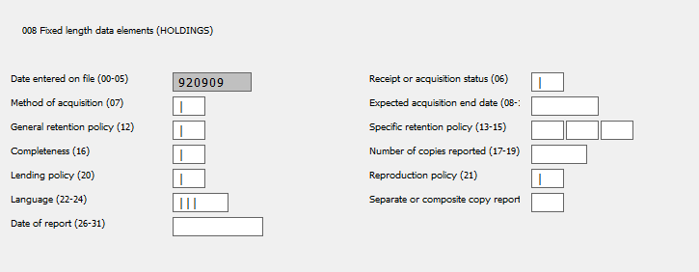

Rule #1 DON’T PANIC. This will just take a few moments of your time to fix and then the world will be a better place for bibliographic control.
If you use your tab key between fields, it will start with element 06 – Receipt or acquisition status. I recommend you use your tab key between fields rather than working top to bottom on the left column then the right.
06 – Receipt or acquisition status. Default: 5 – Not currently received.
Also common at ALF is 2 – received and complete or ceased. Normally it means it is no longer being published and we have all the issues we are likely to get. In our case we may get some gaps filled, but we aren’t actively pursuing this option.

Occasionally we will have 4 – which means we are currently receiving this title. At ALF, this will mostly apply to Government Document serial titles.

07 – Method of acquisition. Default: p – Purchased. Extremely common: d – Depository item.
If you get something with a different code, retain the code that was used.

08-11 – Expected acquisition end date – Do not code.

12 – General retention policy. Default: 8. Retain permanently.

13-15 – Specific retention policy. Do not code. These fields have never been officially defined.

16 – Completeness. Default: 0 - unknown. But, if you know how many pieces the item contains, please estimate and use:
1 – Complete (95-100%)
2 – Incomplete (50-94%)
3 – Scattered (0-49%)
4 – This is a single part monograph, so you will often see this in the field because Aleph assumes all HOLs are for single part monographs.

17-19 Number of copies reported. Default: 001
Some libraries do not record copy 2, copy 3, etc… on different holding records. This tells how many identical items of the same title are on the HOL.

20 – Lending policy. Default: u – Unknown
21 – Reproduction policy. Default: u – Unknown
These two fields tell the Interlibrary Loan departments at other libraries whether we are willing to lend the item via ILL or make a copy of it for them. The code “u” actually is not unknown, but instead refers to a lending policy table from our institution. Other libraries should see that we are willing to lend or reproduce this via that table.

22-24 – Language. Default: whatever is in the BIB record for Language. “eng” for English

25 - Separate or composite copy report. Default: 0 – Separate

26-31 – Date of report. Default: 000000
It is extremely important that this be coded. The Union Listing of items held by UF and FLARE can still be done if some of these fields are blank, but this is not one of them.

Before you know it, you have a beautifully coded record we can all be proud of! Like this example of a non-depository serial that I currently only have a single item for (#10, there should be at least 3 more in the stacks)

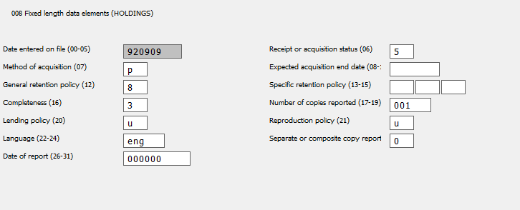

Serials with Two SuDoc Call Numbers
Use the most recent call number
Add the older call number as a “z” public note in the pairs field
Bibliographic record should include an 086 field for each SuDoc number
Withdrawals from AMES
If you have to request a government document be pwd’d (permanently withdrawn) from general storage material collection within AMES to be trayed with government documents you will need replace the barcode on the item before returning to team tray for processing into the government documents collection. Make sure you update the barcode on the UF and the FLARE side of Aleph before sending to team tray.

